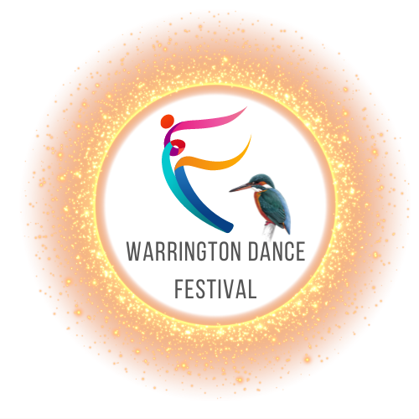
We would like to invite your school to take part in the
Warrington Dance Festival

13th / 14th / 20th / 21st
June 2026
@ St Helens Town Hall
Victoria Square, Saint Helens WA10 1HP

Sections: Ballet, Tap, Modern, Acro, Song & Dance, Character, Lyrical, Musical Comedy, Contemporary, Commercial. Classical and Cabaret duets, trios, quartets and Troupes.

Open section is having won a first place in the relevant novice section. Please place O for Open and N for Novice section on the Entry forms.
Troupes and larger sections will be the second weekend

Closing date: 10th May 2026
(Or until the event is full – first come basis applies. We have a strict time limit at the venue.)

Fees payable via bank transfer to 08-92-99 69828553

Please contact us with any enquiries on email info@kingfisherdanceevents.com or see our website: kingfisherdanceevents.com

Looking forward to seeing you, Jennie and Dianne.

Trophies awarded to winners of each section.
Medals given for 1st, 2nd, 3rd and 4th place.

