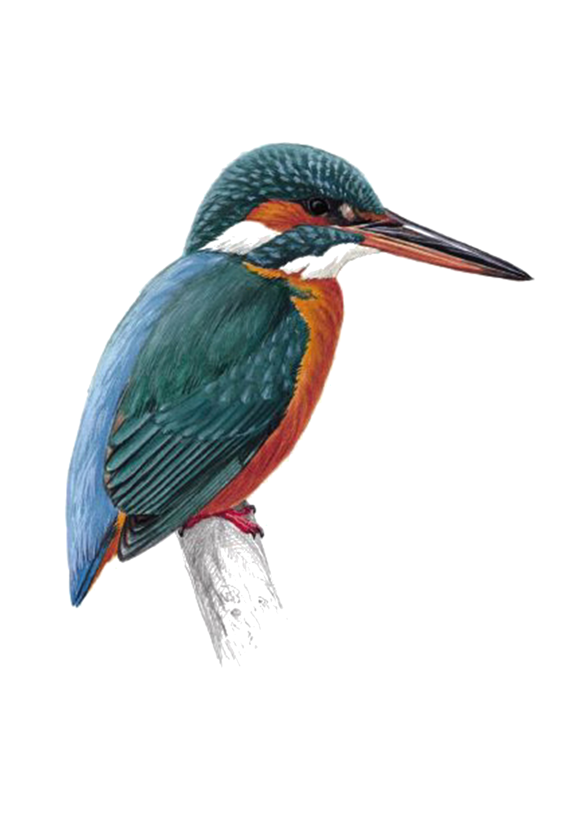

Fledglings Festival

We would like to invite your school to take part in our
Fledglings Festival.
This is a NOVICE only festival.

Small sections, friendly atmosphere, a great festival experience for novice and new competitors.

Sunday 22nd March 2026
Central performing arts studio
Denton M34 3SG

Sections: Ballet, Tap, Modern, Song & Dance, Lyrical
Cabaret and Classical only for Baby section, Duets and Trios

Age groups:
Baby: age 2-6 A: age 7+8 B: age 9+10 C: age 11+12 D: age 13+14 E: age 15+

Fees are: Solos = £7
Duets/trios = £6/ £5 per competitor

Closing date: 22nd February 2026
(Or until the event is full – first come basis applies. Limited sections.)

Fees payable via bank transfer to 08-92-99 69828553

Please contact us with any enquiries email info@kingfisherdanceevents.com or see our website: www.kingfisherdanceevents.com or facebook page Kingfisher dance events

Looking forward to seeing you, Jennie and Dianne.

There is FREE parking at the venue
Trophies awarded to winners of each section.
Medals given for 2nd, 3rd and 4th place.

